Dear Customer,
We want to inform you that we have reduced the green tea/EGCG in our Nutrivene Polyphenol Support with Green Tea product from 600 mg (300 mg EGCG) to 300 mg (150 mg EGCG) per 4 capsules. This change was made out of an abundance of caution to reduce any risk of potential liver damage. The FDA recommends consuming green tea extract with foods and limiting dosages of green tea to 250-500 mg. In rare instances, exceeding these dosages and taking the ingredient on an empty stomach may lead to liver damage. Excessive dosing levels have been described as 900 mg or greater where injury of liver is observed.
Prescription medications may also interact with green tea. Should you have concerns regarding any medications your child or family member is taking along with green tea products, please consult your pharmacist, medical doctor, or contact us and we can consult with our own pharmacist.
It’s important to note that we have never received any concerns or complaints regarding liver damage from customers we work with that take our Nutrivene Polyphenol Support with Green Tea or Nutrivene Green tea products. This change is being made to coincide with FDA recommendations on green tea.
Should you have any questions or concerns, please contact us directly.
Sincerely,
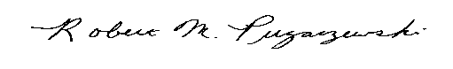
Robert M. Pugaczewski
President

