June 1st, 2016
Dear Customer,
The Pharmacy Compounding Advisory Committee of the U.S. Food and Drug Administration voted not to add Piracetam to a list of approved bulk drug substances this year. Since Piracetam was not added to this approved drug substance list, we will no longer be able to offer this compounded nootropic, even with a prescription from a doctor.

According to section 503A of the Federal Food, Drug, and Cosmetic Act, bulk drug substances may be compounded even though they are not subject to United States Pharmacopeia or National Formulary monograph nor components of drugs approved by the FDA. However, they must be on the approved list.
Should there be a change in status for Piracetam, we will let you know. Please contact us if you have any questions or need further information.
Sincerely,
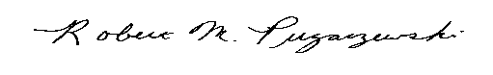
Robert M. Pugaczewski
President

